**Brainstorm session results**

During the brainstorm session, each group member created 3-5 sketches by hand, Notability or Invision Freehand. Some sketches address one or more key tasks, and some are specific details of potential features. We then used discord and Zoom to evaluate and discuss the strengths, weaknesses and feasibilities with regard to our design requirements. Below are three samples from our brainstorm session.

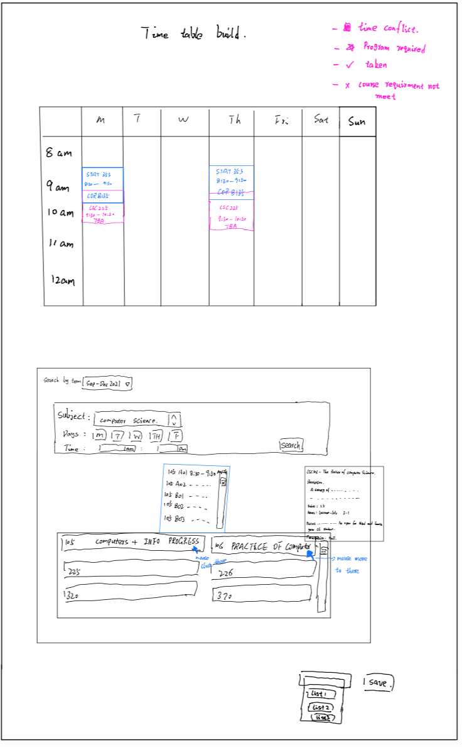

The sketch above demonstrates the timetable builder. Below the timetable is the search bar, which supports searching by subject, course name, CRN, or time. In the list of classes shown, a tooltip of information pops up if the mouse hovers over a course. Clicking on a course reveals its sections. Drag-and-dropping a section in the timetable area "selects" it. Students can save and rename a schedule for later uses.

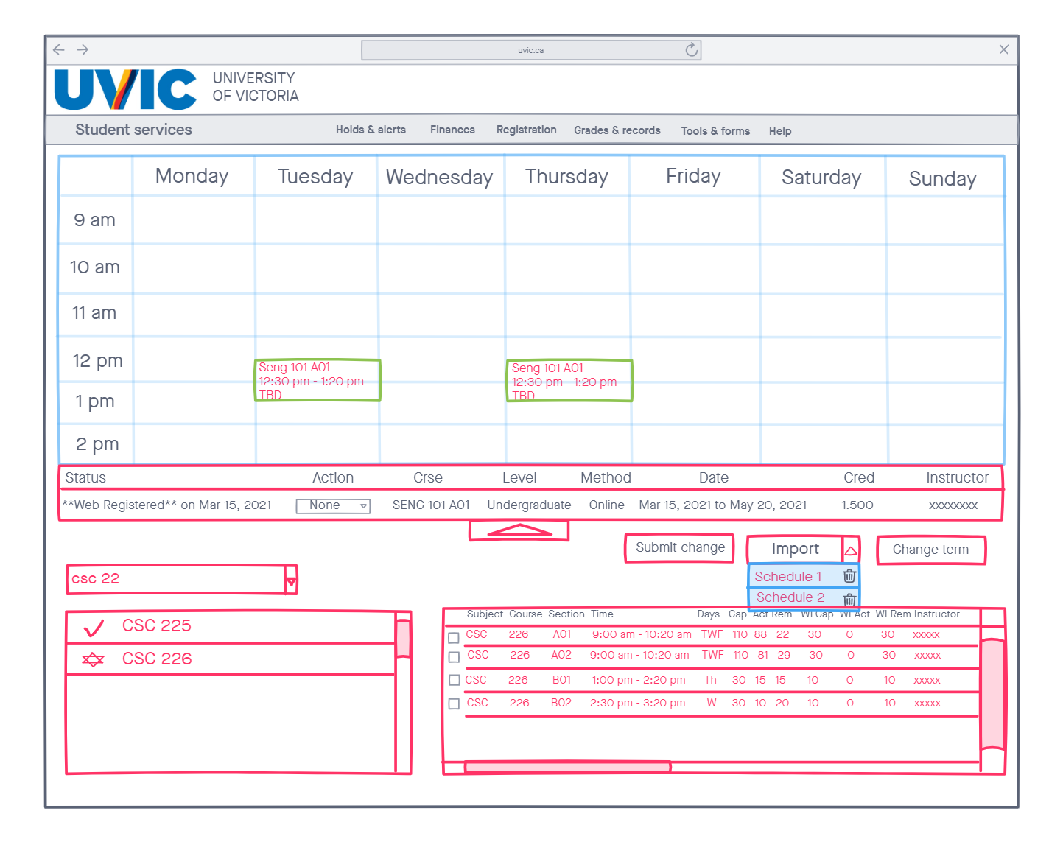

The sketch above presents the "add or drop classes" tool. The "import" button automatically registers all courses in the selected schedule, saved in the "timetable builder". The bottom left is the search bar, search result, while the bottom right shows the selected course information. Just like the previous sketch, it supports drag-and-drop.

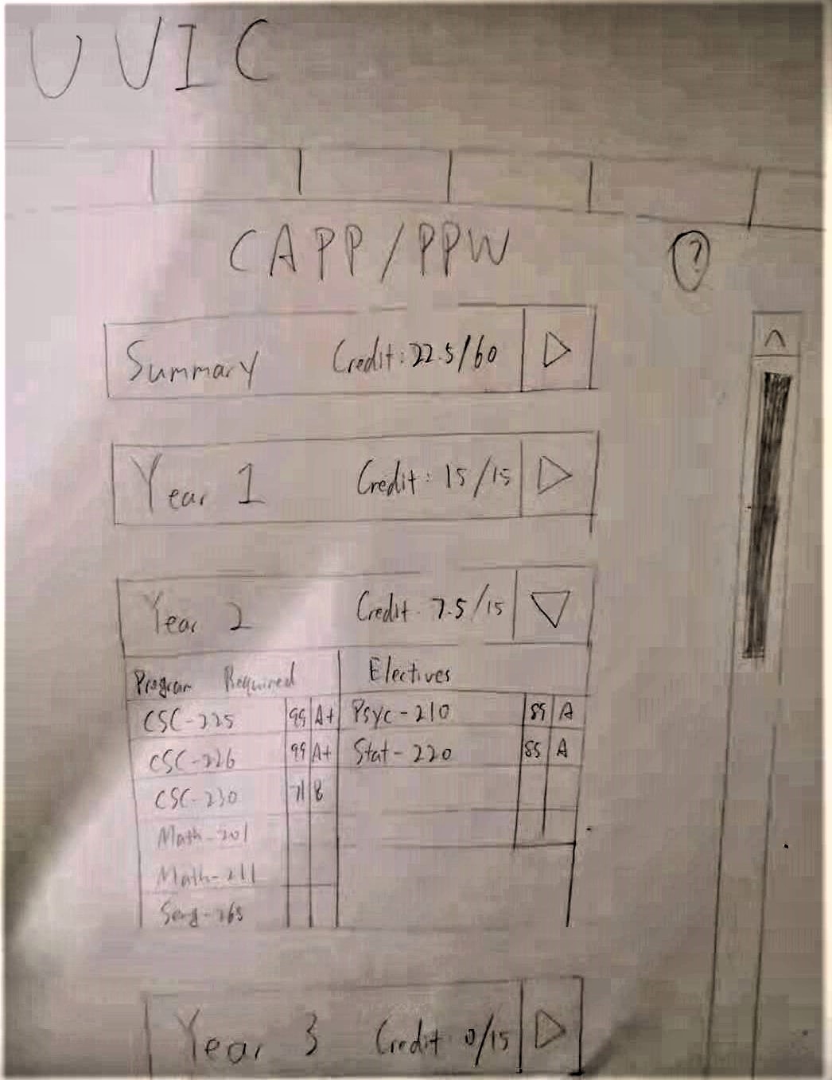

Above is an idea of the new CAPP/PPW. It provides convenience to the users by providing the ability to hide or expand each category. "Summary" shows the total credits, program-required and elective credit count, each separated into lower- and upper-level, as well as a list of all courses taken so far. It also shows each year's credit count, with program-required courses on the left and electives on the right.

Overall our brainstorm and group discussion was successful. Every member contributed with creative solutions and suggestions, and many unnoticed details were brought up and addressed during the discussion. The discussion lasted around 90 to 100 minutes, which was unexpected. The most challenging part was conveying ideas and questions about others' sketches, although Zoom's annotation features helped a lot. Next time during a group discussion, we would introduce a rating system to highlight the best idea without bias.

**Storyboard**

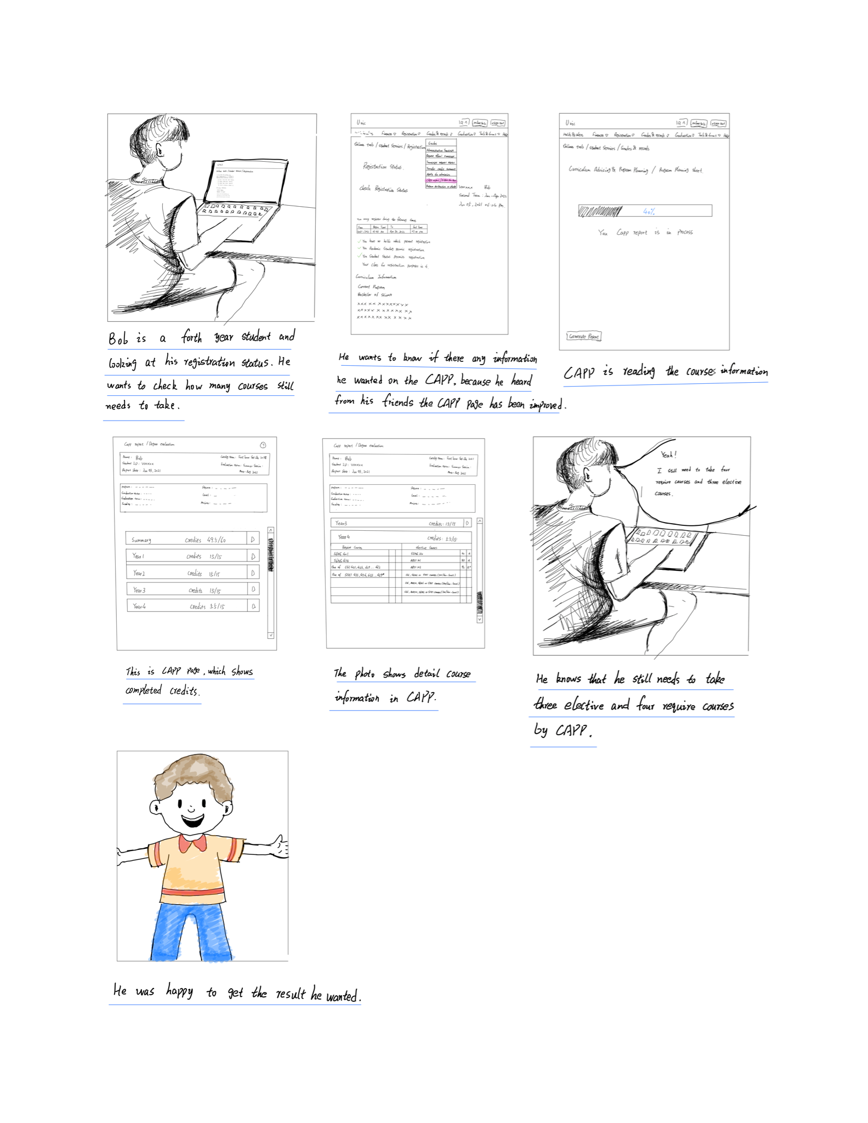

Bob is a fourth-year student. He wants to know how many required courses and electives he still needs in order to graduate. Although the old CAPP did its job, it was difficult for Bob to calculate his upper-level credits, as the form does not provide a clear indication. While generating the form, he realizes that it loads much quicker than before. After the quick load, he finds all the information: total credits, program-required credit count and elective credit count separated into upper- and lower-levels, all of his taken courses and their grades. He can easily tell that there are three upper-level electives and one program-required course that he needs to take. Happy with the new CAPP form, Bob plans out his last semester.

**reflection**

what went well

- It is easier to understand for people using storyboards than words.

what went poorly

- Limitation of painting skill, some photos may not be good.

what would be changed

- Notability is not designed for painting. Next time I may find a special application for painting.

**Video prototype**

**Video prototype:**

The video prototype shows task 1 from our previous assignment. Alex, a new student at UVIC, has no clue what to do. They use the "Help" tool in the new CRS and follow the tutorial. After the tutorial, they get a general idea of the purpose of each tool.

reflection:

what went well:

-slide creation went well

- Zoom provides all the features we want for making the video.

what went poorly:

- Time is too short for us to ensure our video quality

**heuristic evaluations**

Ratings：

0- not a problem

1- minor inconveniences

2- minor usability problem

3- major usability problem

4- not usable at all

### **Visibility of System Status**

rating: 0

reason: The user can clearly tell at which stage the tutorial is on.

### **Match Between System and Real-World**

rating: 0

reason: The tutorial contains no jargon and is very simple to understand. It follows a top to bottom order.

### **User Control and Freedom**

rating: 1

reason: Although the user is in complete control of the pacing, there is no "previous page" option.

### **Consistency and Standards**

rating: 2

reason: Each example page of "add or drop classes", "timetable builder", "weekly timetable" and "CAPP/PPW" has a bright background with black texts, compared to the rest of the tutorial having a dark background and white texts. Also said black texts are in various positions on the screen.

### **Help Users Recognize, Diagnose, and recover from errors**

rating: 0

reason: if the error occurs during the registration period, just refresh the webpage.

### **Error Prevention**

rating: 1

reason: It is improbable any error would occur during the tutorial, although in case any user clicks on the "Help" by mistake, there is no warning.

### **Recognition Rather Than Recall**

rating: 1

reason: Although it requires the user to memorize the general functionality of each tool, the user can return to this tutorial at any time.

### **Aesthetic and Minimalist Design**

rating: 1

reason: Most pages have minimal text, while the "timetable builder" page contains more than any other page.

### **Flexibility and Efficiency of Use**

rating: 0

reason: User can import the course from time table builder to registration

### **Help and Documentation**

rating: 0

reason: This is the tutorial.

________________________________________________________________

**presentation script:**

**slide 1: introduction**

Hello everyone, This is team six. I’m Rui. We have Zhanchi, Aaron, and Junhong.

Today, I will talk about our Low-fidelity prototype of the UVic course registration system.

**slide 2:brainstorm session**

Here is the result of our brainstorm session. We came up with a total of 14 sketches to improve the CRS. And we choose three of the more feasible sketches to talk about in detail.

**slide 3: add or drop classes**

Our first sketch is about the “add or drop classes” tool. At the top of the page, we provide a timetable that includes the registered and waitlist classes in a selected semester, so the user can have a better visualization of how their classes are distributed. The drop-down list under the timetable displays all the currently registered courses, including waitlisted ones. The search bar here supports searching by course names so that students don’t need to memorize or write down the CRN of each class. The bottom left box is the search results, and next to course names there will be symbols that indicate taken courses, program-required courses, and courses that have prerequisites that the student hasn't met yet. Then the students can select sessions in the bottom right box to preview them in the timetable. It is not shown here, but previewed sessions will have an animated border. students can register in their desired sessions by checking the small box beside the sessions and clicking “submit change”. Students can awelso import saved schedules from timetable builders.

**slide 4: timetable builder**

In the second sketch, we wonder to mention this timetable builder. This timetable builder allows students to check the course detail information, manage the time for the course and save the list of the courses for future course registration. Firstly, students decide the subject and the date for the courses. Once students decide the date and courses, the bottom will pop up the list of all of the courses which are satisfied. when students place the mouse on the courses will show the detailed information of the course and click the course will show all the sections for the course lab and tutorials. when students decide the sections for the course will show on the timetable. If there is a time conflict will let students choose another section otherwise it allows students to save the list of classes for future registration.

This is a sketch of the timetable builder. It has a similar design to add or drop classes. The main difference is that a tooltip will pop up when a cursor hovers over a course. The tooltip displays detailed information about the course. After finishing a schedule, students can save the schedule with custom names.

In the second sketch, we wonder to mention timetable builders. The features of this page are really similar to the add or drop courses. So I will mainly focus on the different features such as “save lists”.

**slide 5: CAPP/PPW**

In the CAPP slide, We designed five small parts for CAPP. The first part is the summary part which includes all credits you completed. For the other four parts, we divide all courses students need to take into 4 years. You could view the courses’ information by clicking on the inverted triangle button at the end of each line. After clicking, It has two columns, one is required courses, another one is the elective courses. The grade of completed courses would be shown after the course’s names.

In this sketch of the CAPP/PPW form, we split it into 5 sections, a summary and 1 for each year. The summary shows the total credits and calculates the remaining lower- and upper-level program required credits and elective credits, as well as a list of all taken courses. Each year is also divided into program required and elective courses for clarity.

**slide6: brainstorm session result**

From our brainstorm session, we decided to merge a couple of existing tools and add a few new ones. We merge “lookup classes” into “timetable builder”, “waitlist” into “add or drop classes”, “view active registration” and “detailed timetable” into “weekly timetable” because they either have very similar functionalities or are not used very frequently.

**slide7 Q&A :**

This is our presentation. Thank you. Are there any questions?

-to do list:

-reflections

-video: script and description

-heuristic evaluation

-lab presentation: ppt and script

**He checks and saves the class list from the lookup course. When the registration starts, he can import the class to the actual register webpage. After importing the course, he can visualize his classes schedule on the timetable above for the new semester. Using our new design website can save his valuable time for registration.zhan**

Those technology allowed us to develop many good ideas 我们讨论出了可行性最高的方案，并画出了图像

We use “Zoom” to build our brainstorm session. Zoom is helpful to let us share different ideas. After we discussed the idea then we used the feasible plan to get the result. Our group members use hand drawing,notability and Invision Freehand to sketch our brainstorm session. The hand drawing is easy to expand our limited idea. The notability and Invision Freehand allowed us to pen tools, insert the grid of the text box.

我们通过zoom 共享屏幕 然后使用电脑的win 画图功能 根据我们assignment2 中的task中出现的问题 我们每个人 都尝试着想不同的方案来解决 学生们遇到的问题

描述用什么工具完成画图

用的这个工具的原因

每个人的想法然后画出来还有画多少图（两个人可以画草图 两个人画细节图）

为了完成每个需求我们需要自己问自己 用户为什会出现这样的问题 应该怎么去解决这样的问题 “如何才能满足用户的需求“

（然后根据每个人画的图，进行完善讨论 根据现有的图提出更多新的想法

根据可行性和优缺点来看想出最好的一个方法，根据这个想法，再结合被筛除掉idea 中的一些可行方案） （这个过程我们可以记录下来写在里面）

1. 视频说明
2. 线下选课
3. 小窗口帮助
4. 重新设计更合理页面

reflection:

what went well

-A lot of unnoticed details were brought up

-Every member contributed with creative ideas

-Everyone drew few photos to solve the problem of CRS

what went poorly

-discussion took a lot longer than expected (around 90 minutes)

- online environment make group discussion harder(have to use application tools to show ideas)

what would be changed

- We will use better application tools to improve our discussion efficiently.

- better communication to reduce misunderstanding

idea1 : 图画 一个学生坐在电脑前满头问号 看着电脑屏幕生气 对于这样的问题 我们重新设计选课页面参考proposal

idea2 : 图画 一个学生和电脑页面 然后页面中有课程冲突的课 然后画一个多开窗口 表示对比每节课的时间 重新选课 需要讨论一下 可以放到选课页面中 课的后面加个小问号什么的 显示课程描述 和课程时间 或者不同颜色注释 同样适用于3

idea3 : 图画 一个大三的学生 选了一门课 然后点击确认后 然后弹出一个窗口显示前置课没完成

idea4 : 图画 一个大四学生 看着杂乱的capp 页面 满头问头，将页面分成俩部分， 一部分显示必修，必修课用两个星号代表， 一部分显示用绿色 显示可以选的选修， 然后完成过的有对勾，最后

task1:新生不知道怎么选课室友教如何选课单纯，解决选课问题 capp、PPW找不到、不会选

video ppt

task2：大一学生在宿舍想把课安排在一起， 解决时间冲突问题 报课时间表显示不清

task3：大三学生的选修课要看前置课，解决 课程描述问题

task4：看不了capp的毕业要求， 解决capp 布局和 计算完成/未完成课问题

storyboard

story board

假设tom是个不住学校的新生

1.(看到邮箱邀请邮件很高兴)

2.(点击页面进去login in)

3. 用proposal中的页面

4. 页面信息介绍 例如 必修课 展示 然后课程时间课程描述的按钮位置 讨论一下页面布局 然后页面细节信息展示

5. 同很快完成了注册

ppt:

This is a tutorial for new students who just come to UVIC and know nothing about our CRS.

In the first page, the only thing that students should do is clicking on the help button. Then, a special gift for new student will appear.

这个tutorial 主要是给新生讲解如何简单 使用选课和取消选择课，如何规划coming sesmeter 的课程， 如何使用周课表，如何使用ppw.

通过点击 add or drop classes这个按钮 You will use this tool to add or drop classes, and monitor waitlisted classes.

在 add or drop classes 页面，你可以通过页面中展示的 搜课选择不同的学期 然后搜课，然后拖拽加减课，保存更改后即可完成选课

下一个功能是，规划将至学期的课程选择，这里跟add or drop classes 十分相似，也是一样的操作方法，唯一不同的是 可以在这个页面保存你规划的课程，方便直接在选课时候导入

下一个是weekly table， 这个页面你可以看到，本周你将要上课的时间，教室等基本信息，同时我们还在这个页面增加了加减课选项

最后我们要讲的是capp 或者 ppw， 这里我们对capp页面布局重新设计，在这个页面将会显示你每一年需要修课的详细课程信息，对于修过的课会有成绩显示，页面很直观的告诉你需要上什么课。

这个tutorial 主要是给新生讲解如何简单 使用选课和取消选择课，如何规划coming sesmeter 的课程， 如何使用周课表，如何使用ppw.

我是新生alex，下个月将是我第一个学期在uvic上课，学校发邮件提醒我需要选课了我按那个regraistion的help按钮，

My name is Alex, I am a new student at UVic and I can’t wait to start my university life! Let me see, what do all these do, where do I start? Oh, there is a help button, I better check it out before doing anything wrong.

These are the tools for planning, registering, and viewing courses. Huh, what does that mean? Let me go to the next page.

This is the tool for registering. I will use this tool to add or drop classes, monitor waitlisted classes, and import saved schedules. Okay, what does import saved schedule mean?

This is the add or drop classes tool. More information can be found on the page. Alright, there is a timetable, a search bar, and two other boxes? What exactly does the import do?

Timetable builder allows me to preview courses in future semesters. I can explore different combinations of courses without registering. I can save these schedules and import to add or drop classes to automatically register courses I selected. Oh nice!

I can see it’s kinda similar to the add or drop tool, and there is a save button at the bottom.

Weekly timetable shows my schedule for the week. More course information can be viewed by hovering my cursor over a class. I can check out my daily schedule, awesome.

It looks pretty nice.

Curriculum Advising and Program Planning (CAPP), or Program Planning Worksheet (PPW), CAPP or PPW, it shows a journey map of my department, or my major. Program planning...so I guess I can plan out my whole university life using this? Cool.

Summary year 1, year 2.. It really shows everything! I better check this out after the tutorial.

Oh that’s the whole tutorial! I know where to start now!

planning 下图为规划课页面， 在下面方框中，106鼠标放上面3秒显示detail information and description 105的话点击一下会显示lab的时间和section之类的

search bar 默认是收起来的

选课

可以import在timetable builder里保存的schedule

点一下右边的section可以在timetable上看到预览，可同时预览主课和lab和tutorial

上图为选课页面

our